Safeties and Defensive Play
Or should we say…
Alternative Offense
So, I was playing league last week and watched several individuals make this mistake. They were playing eight ball, one player had two balls left, the other had three, and let’s say the individuals of interest were playing stripes. The 11 ball was buried between three solids and they had ball in hand. (See Fig 1.) The mistake they made? They shot the 12 ball in. Why is that a mistake? I’ll answer that in a minute. First, let’s talk about safeties and defensive play first.
Fig.1
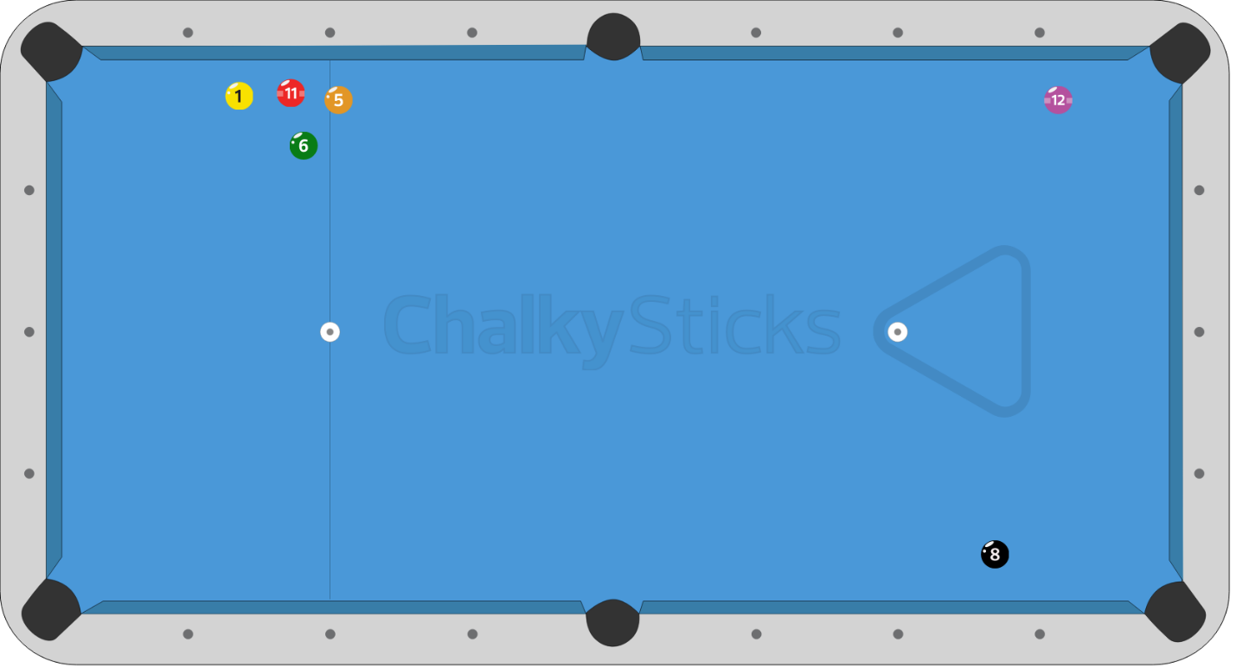

The accepted definition of a defensive shot is any shot that you take with the intention of not making a ball. A safety is arranging the balls in a way so that your opponent doesn’t have an easy shot, usually by hiding the cue ball. So in general terms, a safety is a defensive shot. In contrast to that, an offensive shot is where you try to make a ball. Is there a situation where you can use a defensive shot offensively? Oh yeah! There is an old football expression that goes, “The best offense is a good defense”. It’s the same with pool. Knowing how to play good defense will get you ball in hand more often, and with more ball in hand situations, the more opportunity to run out. Many top rated players will look at a table and working back from the eight ball will find a run out, but, they can’t get the first ball. What do they do? Play a lock up safety somewhere that might get them ball in hand. Then they run the table.
Defensive shooting gets kind of a bad rap. We are taught to shoot to make a ball. Every shot is the opportunity to run out. Some pros even refer it as “chicken pool”. Here’s the rub. When someone hits a home run in baseball everyone cheers. When a pro basketball player hits a three pointer the crowd goes wild. When a quarter back hits his receiver for a 50 yd. touch down the crowd goes ballistic. When Efron Reyes makes a triple bank kick shot the crowd stands and applauds. On the other side of that, if an outfielder leaps and catches that homerun before it makes it to the stands, the announcer says, “He got robbed”. If the quarterback gets sacked before getting that pass off the crowd sighs a collective sigh and is basically quiet. What I am getting at is defensive play is boring. It takes patience and forethought. Everyone wants to go out and run the table every time. I’d like to be able to run the table once in a while. In reality, it isn’t going to happen as often as we want and if we “go for it” every time we are going to leave opportunity at the door of our opponent, so we have to weigh the possibility of making shots to what we leave our opponent, and if the possibility is low that we will run out we need to think defensively, or as I like to think of it, Alternative Offense.
When should we consider using safeties and defensive shots? It should be an option every time you approach the table. Look at the table, find the pattern you want. Maybe it’s a run out. Maybe you can only see 3 balls down the line. The trick is to recognize how far in your run you can go and find a good place to hide the cue ball, or some way cluster up your opponents balls. Simply put, you want to set up your balls for an easy run out while making it more difficult for your opponent. Here’s the first rule for defensive play. Just because you can make a ball doesn’t mean you should.
OK, let’s refer back to the initial question. You have an easy shot but your next and last ball is in the middle of a cluster. You have 3 options. Number 1, (Fig. 2) if you can pocket that existing ball and bring the cue ball around to break up the cluster you might get a shot at that last ball. Number 2, (Fig. 3) you can make the ball and take a chance on getting a look at your last ball and maybe getting lucky. Finally, number 3, (Fig. 4) you could intentionally miss making that ball, leaving it close to a pocket and putting the cue ball where your opponent has a difficult breakout.
Let’s look at these one by one. (Fig. 2) You have ball in hand on your second to last ball. You would have to try and put some right spin on the cue that will take it around the table and hopefully hit the cluster. If you are a “fairly good” shot with good ball control, I would put the chances of hitting the cluster at around 30%. Less if you think that you would get a good shot on your last ball. The next problem is that if you do break up the cluster and don’t run out, your opponent now has the advantage.
Fig. 2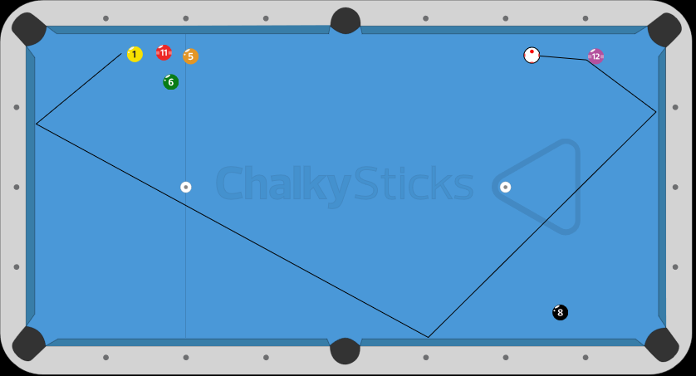

The second option, (Fig. 3) making your ball and getting a look at the ball in the cluster doesn’t work either. Even if you get a look and hit your ball the likelihood that you pocket your ball is small and you break up the cluster and your opponent runs out.
Fig. 3
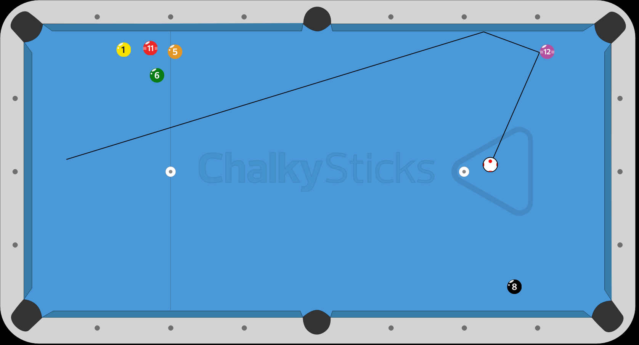
The final option is to intentionally miss making your ball. (Fig. 4) This leaves you set up for an easy shot later and forces your opponent to break up that cluster. The chances that your opponent can break up this cluster, pocket a ball, and have another shot is very unlikely. You’ve already set up an easy shot, your opponent breaks up the cluster, you run out, you win the game.
Fig. 4
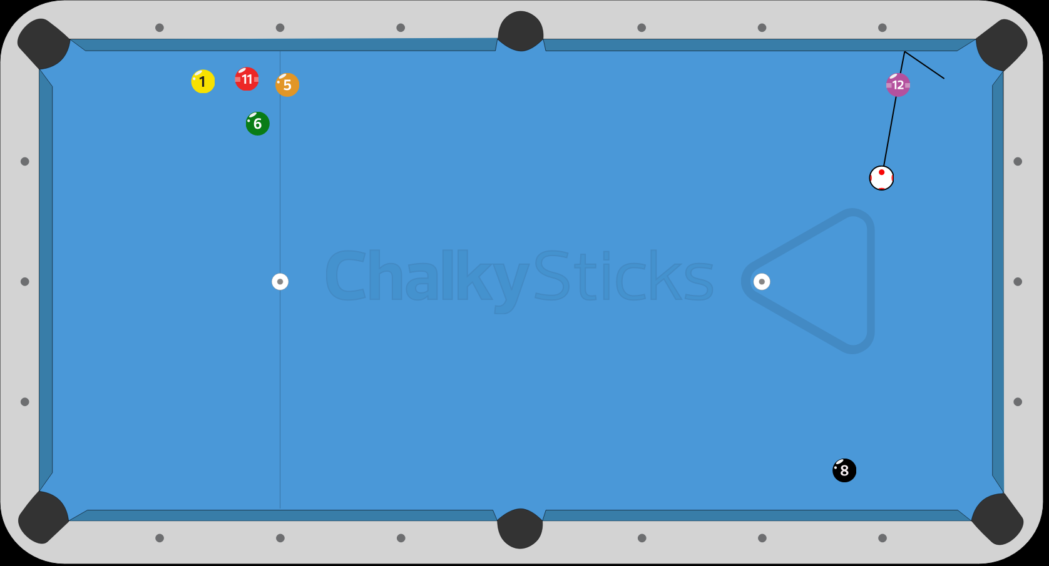
Jerry Briesath has a rule for this. He says if you can’t run 8 balls don’t run 7. Think about that. In eight ball you have either stripes or solids. Meaning that you are going to shoot 7 balls (stripes or solids), and then the 8. Don’t back yourself into a corner and leave yourself only one ball to shoot at. It gives the other person to many ways to hide the cue ball. Don’t give your opponent an easy out or ball in hand. Leave something easy to shoot at. Either break up your clusters early or let your opponent break up it up late.
Now, as I said before, just because you can make a shot doesn’t mean you should. Let’s consider 9 ball for this example. You are shooting at the 1 ball along the short rail. (Fig 5) The 2 is near the pocket of the other far rail. You have a straight in shot on the 1 but no good options on pocketing it. Also, there is to clear path to get on the 2. Look at all the balls on the table. They all have an easy pocket. Then start looking to see if there is a pattern to the 9. 2 ball is easy and lends itself to setting up the 3. If you can get straight on the 3 it’s a stop shot to the 4. A draw shot to get on the 5. Top right off the 5 takes you two rails to the 6, stop shot and you’re on the 7, draw to the 8 and you are on the nine to finish. But you can’t make the 1. However, if you can get ball in hand you could run out the rack. Play a safety. Bump the 1 ball off the rail so it goes beyond the 7 and 8. Stop the cue ball or run it to back of the 8. Now your opponent has the problem. If he doesn’t mess up the table to bad you could have ball in hand and run out. Fig. 6 is your test. What do you do? Hint. Think Figure 5
Fig. 5
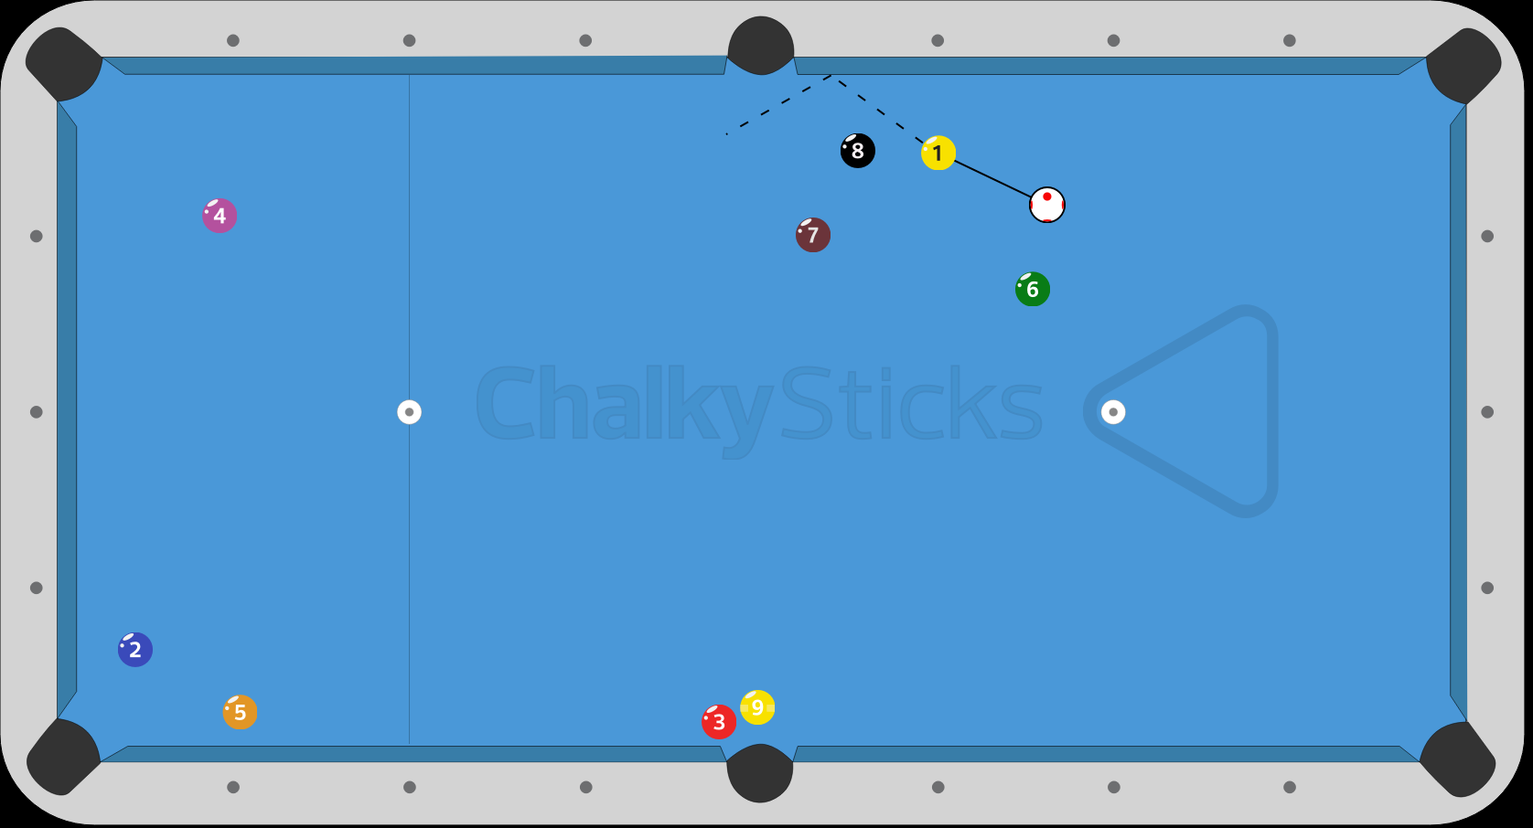

Fig. 6