The Tangent Line

It surprises me that there are so many people who love to play pool but have no clue what the Tangent Line is or why it is so important to the game of pool. There are even some really good players that don’t know what it is. That’s unfortunate, because in my estimation, after the stroke, the tangent line is probably the most important concept you need to know to play good pool. Understanding the Tangent Line tells you what direction the cue ball is going to go after each, and every shot. This is a huge advantage as you plan your runout strategy. So, what is the Tangent Line?
The Tangent Line is the is the direction the cue ball travels after you hit the object ball as a stop shot. Sounds easy? The concept is easy. The execution? Well let’s say there is a lot to understand. So let’s break it down and start with the Stop Shot.
The Stop Shot
If you hit the cue ball so that it has no forward or backward spin when it strikes the object ball, that is a stop shot. If you hit the object ball straight on, all of the energy of the cue ball will be transferred into the object ball and the cue ball will stop. That’s how it got its name. However, if you take that same shot and have a half ball hit on the object ball, 50% of the energy will transfer to the object ball and 50% will stay in the cue ball. If you only hit 10% of the object ball only 10% of the energy will be transferred, 90% will stay in the cue ball. (That’s why thin shots have to be hit so hard. Very little of the energy is transferred to the object ball and the cue ball dances all around the table.) It’s still a stop shot, the cue ball has no forward or backward spin, but the cue ball is going to keep moving. It’s going to continue down the Tangent Line.
What makes the stop shot important is that no matter where you hit the object ball, If you hit the cue ball so that it has no forward or reverse spin when it strikes the object ball, no matter the angle or what percent of the ball you hit, the cue ball will depart at exactly 90 degrees from the direction that the object ball goes. That is the Tangent Line. Knowing this you can predict the course of the cue ball with every shot. See the diagram A.
It doesn’t matter where the cue ball is shot from. If it has no spin when it hits the object ball it will travel at 90 degrees from the direction of travel of the object ball. If you hit the object ball with any back spin on the cue ball, the cue ball will move toward the center of the table. If you put top spin on it, it will move toward the corner pocket. And here’s the kicker. If you shoot the cue ball so there is no over spin. (It just rolls over the table like you rolled it out of your hand). The cue ball will deflect 30 degrees off of the original cue ball trajectory. For example, If you splay your fingers, the angle between your middle finger and your index finger is 30 degrees. Lay you middle finger on the line between the cue ball and where you are going to hit the object ball. The index finger points in the direction the cue ball is going to go. See Fig. B. Knowing what the Tangent Line is and what happens when you add forward, or reverse spin is a game changer. Not only can you predict where the cue ball is going but you can break up clusters, avoid scratching, and hide the cue if you need to.
Now, bonus information. Dr. Dave has a video with Sam Diep about this so look it up on you tube. If you hit the object ball as a stop shot but put right or left English on the cue, the tangent line will not be affected. However, when the cue ball contacts the bank, the spin on the cue will make it go right or left. See Figure C.
Do you see the potential? Knowing the tangent line gives us a baseline that we can use to get the cue ball anywhere we want it. This is huge!!!!

Fig. A
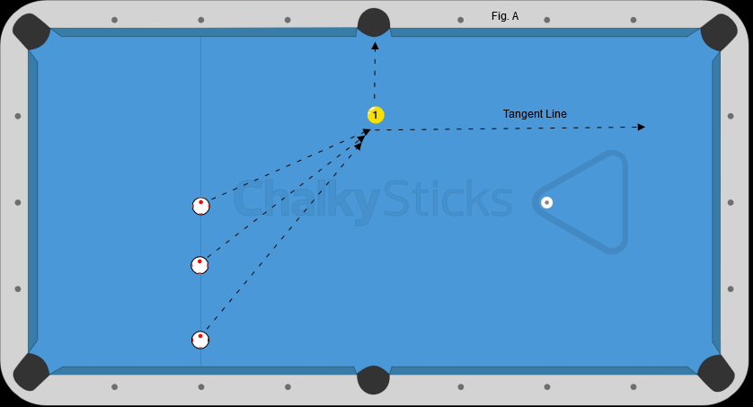

Fig. B
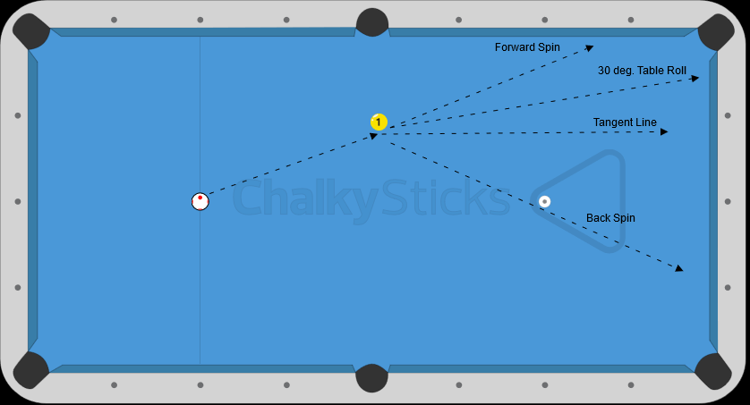

Fig. C
